Project - Deploying Multi-Tier Application on Amazon Web Services Amazon EC2 Using Docker Compose

Objective
Deploy a multi-tier application on an AWS EC2 Ubuntu instance using:
- Docker
- Docker Compose
The application contains:
- Frontend container
- Backend API container
- MySQL database container

Architecture
Browser
|
EC2 Public IP
|
Frontend (Nginx) : 8080
|
Backend API (Flask) : 5000
|
MySQL Database : 3306

Prerequisites
Required:
- AWS Account
- EC2 Ubuntu Instance
- Key Pair (.pem file)
- Security Group
Recommended:
- Ubuntu 22.04
- t2.micro or t2.small

Step 1: Launch EC2 Instance
Go to:
AWS Console
Open:
- EC2 Dashboard
- Launch Instance
Configuration:
Setting | Value
Name | multitier-vm
AMI | Ubuntu Server 22.04
Instance Type | t2.micro
Key Pair | Create/Select existing
Storage | 8 GB
Security Group | Allow required ports

Step 2: Configure Security Group
Allow inbound rules:
Type | Port
SSH | 22
Custom TCP | 8080
Custom TCP | 5000
Source:
- Anywhere (0.0.0.0/0)

Step 3: Connect to EC2 Instance
From terminal

Step 1-8: Remove broken Docker repo
# Add Docker's official GPG key:
sudo apt update
sudo apt install ca-certificates curl
sudo install -m 0755 -d /etc/apt/keyrings
sudo curl -fsSL https://download.docker.com/linux/ubuntu/gpg -o /etc/apt/keyrings/docker.asc
sudo chmod a+r /etc/apt/keyrings/docker.asc

# Add the repository to Apt sources:
sudo tee /etc/apt/sources.list.d/docker.sources <<EOF
Types: deb
URIs: https://download.docker.com/linux/ubuntu
Suites: $(. /etc/os-release && echo "${UBUNTU_CODENAME:-$VERSION_CODENAME}")
Components: stable
Architectures: $(dpkg --print-architecture)
Signed-By: /etc/apt/keyrings/docker.asc
EOF

sudo apt update

sudo apt install docker-ce docker-ce-cli containerd.io docker-buildx-plugin docker-compose-plugin

Step 9: Verify Docker
docker --version

Expected:
Docker version 27.x.x

Step 7: Start Docker Service
sudo systemctl start docker
sudo systemctl enable docker

Check status:
sudo systemctl status docker

Step 8: Add User to Docker Group
sudo usermod -aG docker ubuntu

Apply changes:
newgrp docker

Step 9: Install Docker Compose
Download Docker Compose:
sudo curl -L "https://github.com/docker/compose/releases/download/v2.29.2/docker-compose-linux-x86_64" -o /usr/local/bin/docker-compose

Give execute permission:
sudo chmod +x /usr/local/bin/docker-compose

Verify:
docker-compose --version

Step 10: Create Project Folder
mkdir multitier-app
cd multitier-app

Step 11: Create Folder Structure
mkdir frontend backend

Step 12: Create Frontend Application
Move into frontend folder:
cd frontend

Create HTML file:
nano index.html

Paste:
<!DOCTYPE html>
<html>
<head>
<title>Multi-Tier Application</title>
</head>
<body>
<h1>Frontend Container Running Successfully</h1>
<button onclick="loadData()">Call Backend API</button>
<p id="output"></p>
<script>
async function loadData() {
const response = await fetch("http://54.82.38.43:5000");
const data = await response.text();
document.getElementById("output").innerHTML = data;
}
</script>
</body>
</html>

Replace:
- EC2_PUBLIC_IP
Example:
http://13.233.x.x:5000

Save and exit.

Step 13: Create Frontend Dockerfile
nano Dockerfile

Paste:
FROM nginx:latest
COPY index.html /usr/share/nginx/html/index.html

Save and exit.

Step 14: Create Backend Application
Move back:
cd ..
cd backend

Create Python application:
nano app.py

Paste:
from flask import Flask
from flask_cors import CORS
import mysql.connector
app = Flask(__name__)
CORS(app) # This fixes the browser blocking requests from your frontend
@app.route('/')
def home():
conn = mysql.connector.connect(
host="mysql-db",
user="root",
password="password123",
database="salesdb"
)
cursor = conn.cursor()
cursor.execute("SELECT * FROM customers")
rows = cursor.fetchall()
result = ""
for row in rows:
result += f"{row}<br>"
conn.close()
return result
if __name__ == '__main__':
app.run(host='0.0.0.0', port=5000)

Save and exit.

Step 15: Create Requirements File
nano requirements.txt

Paste:
flask
mysql-connector-python
flask-cors

Save and exit.

Step 16: Create Backend Dockerfile
nano Dockerfile

Paste:
FROM python:3.10
WORKDIR /app
COPY requirements.txt .
RUN pip install -r requirements.txt
COPY . .
CMD ["python", "app.py"]

Save and exit.

Step 17: Create Docker Compose File
Move back:
cd ..

Create compose file:
nano docker-compose.yml

Paste this:
version: '3'
services:
frontend:
build: ./frontend
ports:
- "8080:80"

backend:
build: ./backend
ports:
- "5000:5000"

depends_on:
- mysql-db

mysql-db:
image: mysql:8

container_name: mysql-db

restart: always

environment:
MYSQL_ROOT_PASSWORD: password123
MYSQL_DATABASE: salesdb
ports:
- "3306:3306"

volumes:
- mysql-data:/var/lib/mysql
volumes:
mysql-data:

Save and exit:
- Press CTRL + X
- Press Y
- Press ENTER

Step 18: Remove Old Containers and Volumes
docker-compose down -v

Step 19: Start Multi-Tier Application
docker-compose up -d

Step 20: Verify Running Containers
docker ps
Expected containers:
- frontend
- backend
- mysql-db

Step 20: Verify Running Containers
docker ps

Expected:
- frontend container
- backend container
- mysql-db container

Step 1: Open MySQL Container Shell
docker exec -it mysql-db bash

Step 2: Login to MySQL
mysql -u root -p

Enter password:
password123

Step 3: Select Database
USE salesdb;

Step 4: Create Table
CREATE TABLE customers (
id INT PRIMARY KEY,
name VARCHAR(50),
city VARCHAR(50)
);

Step 5: Insert Records
IMPORTANT:
Use normal single quotes ‘ not smart quotes ’.
INSERT INTO customers VALUES
(1,'John','New York'),
(2,'Alice','London'),
(3,'Bob','Delhi');

Step 6: Verify Data
SELECT * FROM customers;

Expected output:
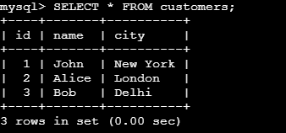

Step 7: Exit MySQL
exit

Step 8: Exit Container
exit

Step 21: Access Frontend Application (Main Page)
Open browser:
http://EC2_PUBLIC_IP:8080

Example:
http://54.196.71.145:8080/

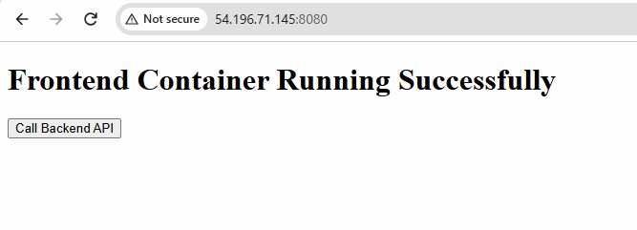
After clicking “Call Backend API” you will get following output
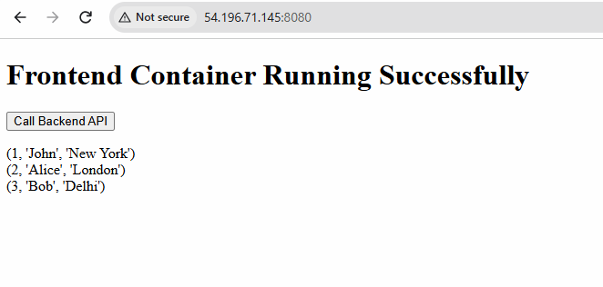

Frontend:
http://54.196.71.145:8080/

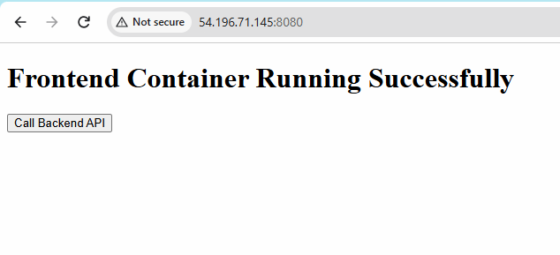
Backend

http://54.196.71.145:5000/

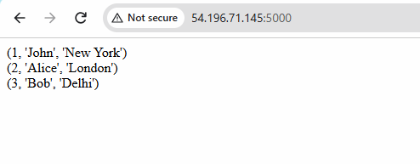

Step 22: Test Backend API
Click:
curl http://localhost:5000

curl http://54.196.71.145:5000

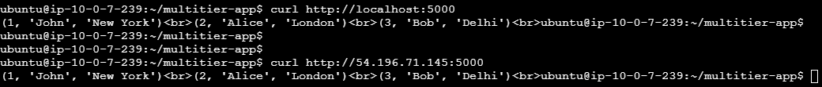

Step 26: Remove Volumes
docker-compose down -v

Expected Result
Component | Status
Frontend | Accessible
Backend API | Accessible
Database | Running
Container Communication | Working

